Weekly Diary – Justin Pornasdoro

# Project Pitch

1. **Cross framework CRUD web app generator\***

The most common type of commercial application is what is known as a CRUD web application. A web interface to a database that is used to digitise the bureaucracy of an organisation. Most professional software developers repeat very similar tasks over and over to create these kinds of web application. The goal of this project is to use as simple a specification as possible to define a CRUD application and then automatically use this specification to produce all of the extra code, html, config and other files needed to create a web application with popular web frameworks.

CRUD applications consist of the following:

Typically, users fill in web forms which have some web logic to prevent users from submitting the forms unless the input is ‘valid’ e.g. date of birth not after the current date.

The forms correspond to ‘objects’ stored in a database. Completing the forms typically create an instance of the object in the database.

There is usually a means of viewing the objects and updating them (i.e., viewing the form filled out and having a save button to update the object instance)

There are then often actions that occur when the forms are completed, usually in the form of causing others to do work, for example sending an email to someone with parts of the email filled out by fields of the object being saved.

Instead of an email the system might create a ticket of work and assign it to a person. These tickets can be viewed through the system.

The systems typically have a user login system

The system also tends to have a logging system keeping track of stats about how it is being used to help management.

Such systems also tend to have an admin interface for viewing the system and logging stats and adding/removing/updating users.

There is a large amount of similarity in these web apps even though they are typically implemented in different programming languages and different web frameworks.

The purpose of this project is to define a minimal set of information that can create the majority of a common CRUD web app project:

Specify the objects that store information using a models.json file,

The set of pages that are visible and the flow between them as a views.json file, most views are automatically generated from the models (they are just means to store an instance of the object)

Some simple logic e.g. store object in database, send email in a contollers.json (views can specify controller logic to be run when a form is complete)

The project is to create one or more ‘back ends’ that take the json files and generate code, framework configs etc. to produce the web app using that framework. The intention is to follow an existing tutorial for creating a CRUD web app (https://blog.miguelgrinberg.com/post/the-flask-mega-tutorial-part-i-hello-world) but alter it so that a python project generates the output of the tutorial from .json configuration files. Going through the full tutorial for a given backend is likely to be too much work but getting the user login, create, update and delete functionality for a given .json working would be a good area to focus on.

Multiple students can work on this project with each student focusing on a different back end language or collaborating to implement one language in greater detail.

# Week 1 – 11/01/21

## Tuesday 12 January 2021

Started to look into the links John had sent me and followed his guidance of using Flask with Python. Luckily, I’ve had a lot of experience with Python due to my computer science A-Level. I watched this video [https://www.youtube.com/watch?v=oC483DTjRXU&ab_channel=CoderFoundry](https://eur02.safelinks.protection.outlook.com/?url=https%3A%2F%2Fwww.youtube.com%2Fwatch%3Fv%3DoC483DTjRXU%26ab_channel%3DCoderFoundry&data=04%7C01%7Cjpornasdoro01%40qub.ac.uk%7C2af550c785d84b57105b08d8b72aa1ea%7Ceaab77eab4a549e3a1e8d6dd23a1f286%7C0%7C0%7C637460741015322575%7CUnknown%7CTWFpbGZsb3d8eyJWIjoiMC4wLjAwMDAiLCJQIjoiV2luMzIiLCJBTiI6Ik1haWwiLCJXVCI6Mn0%3D%7C1000&sdata=44vr9Z5ZUpc2rNQkZ2dbnh7GA%2F3GIWeCIrArVilFrsA%3D&reserved=0). Also read these articles that John had sent me about a Flask Tutorial and MVC for Flask Application which I didn’t really understand.

So, I decided to just get stuck in and find my own tutorial in video format. I found a windows tutorial that went over the basics. ([Flask Tutorial #3 - Adding Bootstrap and Template Inheritance - YouTube](https://www.youtube.com/watch?v=4nzI4RKwb5I&ab_channel=TechWithTim)). I aim by the end of the day to have finished this tutorial and have a re-read of MVC for Flask Application.

It was hard to find a tutorial that was using Windows. I decided to reinstall PyCharm in case of any incorrect installs I have done before.

## Thursday 14 January 2021

Still working through the tutorials, aiming by the end of the day to finish these sets of tutorials, and then moving on to something more advanced. I’ve now learned about sessions, bootstrap themes, incorporated my own navbar and currently working on message flashing.

I have a couple more tutorials that I have to do however I’ve just finished be able to store and retrieve data from a database using SQL. I’ve now moved onto a full stack tutorial ([Fullstack Flask React Tutorial - Master Flask Basics And Build A Python Flask React App | 2020 HD - YouTube](https://www.youtube.com/watch?v=cb1vy1HpVwk&t=3515s&ab_channel=THESHOW)). Finding it pretty hard but I’m getting there. Currently he’s using Visual Studio Code which I’m not sure I need to change. I’ve successfully installed Node.js and React.

## Friday 15January 2021

Tried to continue the tutorial, however, wasn’t working. I’ve decided to take for the rest of the day and try not to burn myself out of coding. Taking your advice John that it’s not a sprint. I am to focus on just react however I may need to ask John if I need to do that. My presumption of my project is kind of a website builder?

## Sunday 17 January 2021

Tried to just mess around with another react tutorial however has no breakthroughs.

# Week 2 – 18/01/21

## Monday 18 January 2021

After clarifying on what my project entails with John. I decided to just start from the group up instead of just blindly following a tutorial! During today I just watched videos on how react works and more importantly where reacts is placed in a MVC paradigm. As I understand it is the View component, Controller component would be flask and the Model would be my database to my understand.

## Tuesday 19 January 2021

I have decided that today, I will be solely focusing on just learning React from the group up and then hopefully trying to connect Flask once I’m comfortable to. I’ll be starting from the official React website to learn this. So, I finished the Tic Tac Toe example but I still don’t really understand. I found a complete beginner’s guide, but it is 5 hours long. This does not really work with how long because I like being fast. However, I’ve hit a point where I feel like I won’t ever get to hang of react and thus failing the module.

## Wednesday 20 January 2021

- Today I will be taking up the format of the example diary that John had given the class.

- For today Ill be following this 5 hour react tutorial ([Learn React JS - Full Course for Beginners - Tutorial 2019 - YouTube](https://www.youtube.com/watch?v=DLX62G4lc44&t=1576s)).

- I’ll be setting small goals today and try not to just set massive goal that doesn’t seem achievable (trying to take baby steps)

- Today I’ll also being using VSCode as it has been recommended to me to be using for react.

- In the first few minute of the tutorial, I realized that the tutorial is supposed to be used with an online React learning environment which required a membership. I then luckily found this update to date free tutorial on making a todo list. ([React JS Crash Course 2021 - YouTube](https://www.youtube.com/watch?v=w7ejDZ8SWv8&t=1424s&ab_channel=CodeDripbyAaronJackCodeDripbyAaronJack)).

- 25 minutes in and it’s still making sense which is a good thing. But I’m afraid I may have to start learning javascript basic concepts.

- Couple more minutes in, I think I’m starting to understand.

- I’m starting to understand the overall structure of a webpage and also how components work with props

## Thursday 21 January 2021

- Still working through the tutorial just trying to take my time and just going through what I just typed instead of just blindly following it.

- I still believe I need to learn the basic concepts on JS as there’s certain things that make sense because of previous language concepts but it is still pretty confusing.

- But I am filling a bit more confident about react however, the concept of making this to be a generator is still far from my grasp.

- Finally finished the pure react tutorial I do get some of it. I’m having a hard time figuring out what’s a variable name and what’s a js construct! I would love to just go through the code with somebody who knows stuff, but I’ll get through it.

- Now I think I have two options, to keep continuing just learning react or start learning how to connect it to flask and re-learn MySQL. I hope to discuss this matter with John tomorrow in our meeting.

## Weekend 22-24 January 2021

- Decided to just try to research the best bootcamp that I can try to duplicate, however didn’t have great success.

- The main problem was there was no full bootcamp that solely focus on the Flask and React. Mostly were a mix of React + Node.Js or another backend

- I did research the pros and cons of node.js against flask and it does seem “easier” to code when both the front and back end are in the same language

- I was also kind of put of due to the fact that I couldn’t do my way of teaching it to myself. Which was just learning flask and react in a more traditional way, learning the basics etc. I do not really like the idea of just following a tutorial and just blindly copying code. I do understand that I will learn some of the code from the bootcamp. But I do understand John’s viewpoint as there isn’t really enough time to focus on each framework so he’s just trying to dedicate as much time as possible to the main focus of the project which is the automation.

# Week 3 – 25/01/21

## Monday 25 January 2021

- So, I’m going to try to be more productive this week. John was saying how we should be on this every day just for small bursts. It’s a marathon not a sprint.

- Found a skillshare fullstack with Node.js and React. I do hope this is a good bootcamp and I do believe knowing node.js would look better on my portfolio and it would help with my overall java programming.

- I will be going through it and trying to think is this an optional thing to add into the application or is this necessary and then I’ll right down the code in a separate word doc. This will help me further down the line when trying to automate this whole process.

- So, the bootcamp has really got me excited, it’s lengthy but it covers three projects, Tic Tac Toe, Movie and Actors searching database and finally an instant messaging service.

- I think the instant messaging service will be valuable as this will allow the creation of a ticket system!

- I finally found another solid foundation I can start from 😊

- So, the pre-requirements of this bootcamp are knowing HTML and CSS which I don’t have any experience in but hopefully I can do this.

- The installed applications are node.js, git (git bash) and bash

- The bootcamp is pretty good so far as it also goes through what extensions should be installed with vscode

## Tuesday 26 January 2021

- Still following the tutorial and being taught the basics of Git which is pretty useful as I’ve never used it before

- Just going over the basics of Node.js, finding it a bit boring and I want to skip it, but I am afraid I’ll miss something

- Just finished going over the basics of React, which I do not really like learning. I am more of seeing how basics work through examples instead of seeing the concept stand alone.

## Wednesday 27 January 2021

- Going to start the first project today which is a basic Tic Tac Toe.

- Already having problems with just install dependencies

- Finally, just do a whole reinstall of the whole react app and got the dependencies working!

- Then just added some lint and prettier.rcs to aid programming

- Running into some really annoying problems which cause me to have to do things that don’t follow the bootcamp to fix them which annoys me a lot because I don’t want it to affect me later down in the bootcamp.

- For example, the eslint enforces this rule on my editor but in the bootcamp it doesn’t enforce it even though we used the same eslint.

## Thursday 28 January 2021

### Aims

- Finish Tic Tac Toe tutorial

- Go over what I’ve learnt from the tutorial

- **Current GitHub Progress:** https://github.com/JustinYuann/TicTacToe

### Thoughts

- JavaScript call back functions are weird, and I need to learn them. I’m using w3schools to try to understand them.

- I’ve been able to follow the tutorial just fine, it’s just I’m blindly coding which I hate. I don’t really feel like I’m learning something.

- I am currently getting stuck on some lines of code that I don’t understand. I feel like I shouldn’t focus on them and just keep going to try to push for the automation, but it just bugs me.

- After some confirmation, I was told to learn some of the aspects that I don’t understand because if you don’t understand what you’re coding how will you learn to automate it

- I am placing comments throughout the code to hopefully try to drill all the information into my brain.

- I’m currently doing my final commits and I was able to start the history function

## Friday 29 January 2021

### Aims

- Finally finish the Tic Tac Toe Tutorial ☹

- Research JSON

### Thoughts

- I feel like I am finally understanding the code, it is just taking me very long for me to understand what the codes means

- I’m really happy and excited to keep learning and starting to finally understand it, it’s just I feel like I’ll be left behind and won’t be able to finish the project.

- I’m feeling a lot of pressure because I still need to figure out the backend and the model

- But since I am in “Groove” I may be able to program a lot during the weekend and hopefully not burn myself out :)

- After the meeting, I feel more confident about the project and the support John can give me.

- I just found another tutorial which is about creating a form and stuff like that so, more tailored to my problem

## Saturday 30 January 2021

### Aims

- Start new bootcamp (leaving the tic tac toe)

- Don’t expect to finish it just get into a groove with it

### Thoughts

- Kind of gutted that I could not finish the original bootcamp but in the end it would only be teaching me React and Node JS, which forgets the database

- I’ll be starting this bootcamp ([Learn React, MongoDB, Nodejs and Express by coding a charts generator | Raymundo CH | Skillshare](https://www.skillshare.com/classes/Learn-React-MongoDB-Nodejs-and-Express-by-coding-a-charts-generator/655300638/projects))

- I have also been looking at parsing JSON files into other languages, and it’s been done before which is a good sign. It’s “Do-able”!

# Week 4 – 1/02/2021

## Overall Aims

- Finish the Bootcamp

- Finish the static HTML webpage

## Monday 1 February 2021

### Aims

- Finish 10 tutorials today (Currently on Tutorial 4!)

### Thoughts

- New week, new mindset

- I feel like I’m not working fast enough so I’m going to push myself more

- My aim for today was going to be “get through the tutorial” but that was too broad and didn’t really give a metric to hit so I decided onto ten videos.

- I choose this because video 10 goes through the final part of APIs

- So, I wanted to just finish a whole topic for one day

- Successfully got done 10 videos which I’m pretty proud of

- I’m now able to create basic APIs that query MongoDB and that also take in user inputs

- I’m deciding to stop today as I don’t want to burn myself out btu also that I need to focus on my other projects

- Tomorrow I am to do more tutorials, I’ll be aiming for 8 as I have an appointment

# Tuesday 2 February 2021

### Aims

- Finish 6 tutorial videos today

- Start the HTML static web page

### Thoughts

- Don’t really feel anything per say, I’m just going through the tutorials and I feel like that’s all I can do at the moment

- Just ran into a bug that didn’t appear in the tutorials and I was able to troubleshoot which I think is pretty good progress

- Did some testing on my APIs and it currently connects to the DB and saves to it!

- Looked onto the other videos and later its start focusing on React which is nice change because I’m working on the model and controller

- One problem is I don’t really know what I’m coding at the moment because I’m not sure if it is node.js or express

- Over the course of this tutorial, I’ve started to become more confident with all the structures which is really great

- Did some more research and figured out the express is another framework on top of node.js which makes it more simpler

- The API is now able to read the data from the MongoDB and successfully return it to the testing software called

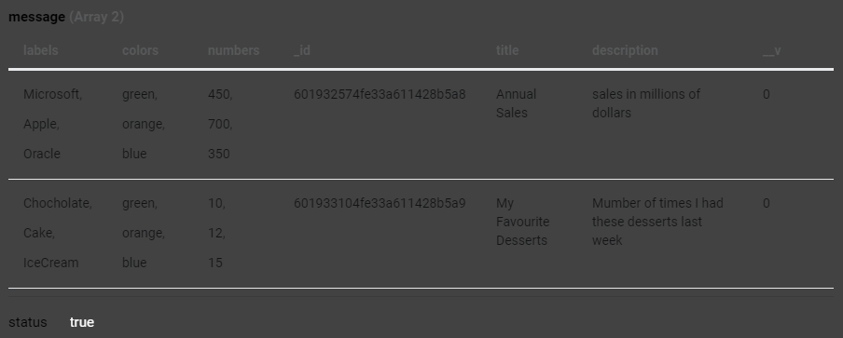- Above you can see the existing objects that I’ve added into the database and was able to retrieve them using this GET method

- I’m feeling like this is all coming together, I’m starting to learn the code and how it works.

- Progressing through the tutorial I can now query a database with a specific ID and retrieve the corresponding object, you can see below



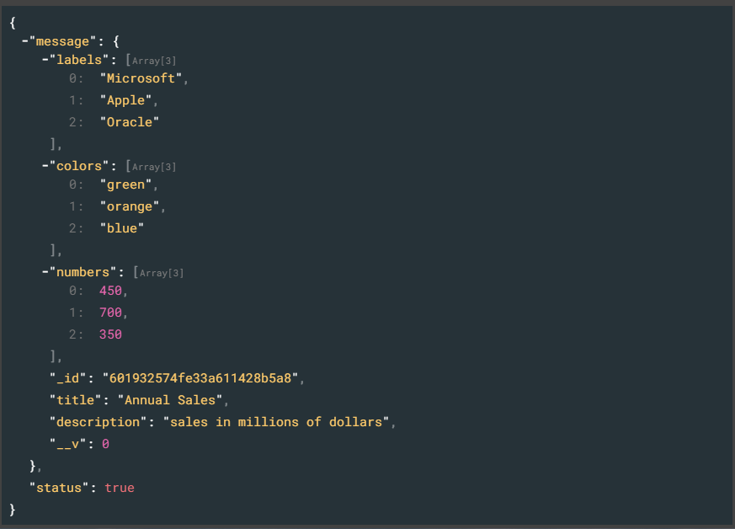

- Ran into some problems due to the tutorial being a whole year old which means a lot more optimisation to the packages.

-Luckily, I was able to troubleshoot and then continue with the tutorials however I do fear there may be a change of syntax that could cause more problems in the future

## Wednesday 3 February 2021

### Aims

- Finish 7 Tutorials

- GitHub Repository: [JustinYuann/ChartGenerator (github.com)](https://github.com/JustinYuann/ChartGenerator)

- Start work on the HTML Static Page

### Thoughts

- Sadly, yesterday I couldn’t start HTML web page due to other modules having to take my time

- I’m starting to worry about my time management skills as I have another ongoing project in my other modules which is group based which adds a lot more complications

- The progress currently is going well, I’m around halfway through the tutorial and I haven’t run into many bugs except some typos I made

- All this web development made it easier to read some HTML code from the HTML Templates and I hope that I can do the page in around a day

- I am using a node module called webpack which is kind of like what I’m making where I must make a template and then it rights the files. I hope to look further into this.

- As I’m going through this tutorial more and more of it is more outdated than what I was taught in the previous bootcamp but I’m able to alter some of it to fit to the new syntax which I’m pretty proud of

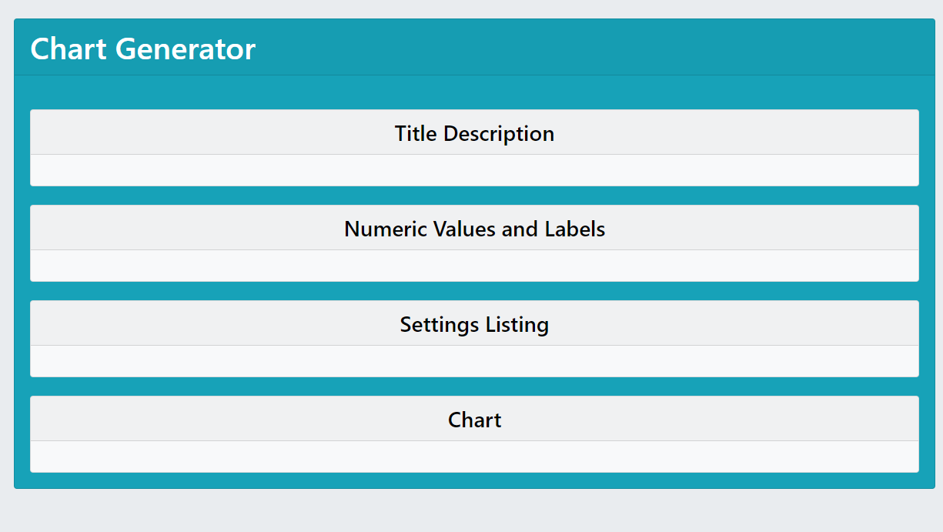

- After a few more videos I was able to create this using Reacts’ Bootstrap which I think I’ll pulling components from in the future

- Currently stumped on a bug that I can’t fix since Reacts’ syntax has been updated

- I was able to start some work on the HTML static page and was surprised on how much HTML code I could understand, probably from all the JS code I’ve been writing.

-Luckily, I was able to still continue the tutorial and finish 7 videos

## Thursday 4 February

### Aims

- Get entry fields to save things to the database!

- Finish HTML web page

### Thoughts

- After an hour of researching documentation, I was able to get an entry value to display.

- The error was a single typo when declaring a component which was annoying

- Today instead of trying to get to a certain number of tutorials, I’ve decided to go until I can save fields into the database.

- But first order on the agenda is getting the HTML page done!

- Got the HTML page done and found it an enjoyable experience.

- But I feel like I ramble to much in it and kind of giving a general guide on how to start any project instead of this one specifically, I probably will go over it again and just read and ask John if that approach is okay.

## Friday 5 February 2021

### Aims

- Re-word HTML static page

- Link the correct GitHub to the page

- Get 5 more video tutorials done

### Thoughts

- I want to re-word my HTML page, I feel like it’s too general

- Of course, there are some areas that are specific to the project but other areas that are more generalised like how I conducted my research and how other should to.

Honestly, not sure but I’ll try my best!

# HTML Static Page Reasoning

I designed my tutorial in a way that would attract a person like me, a person that’s jumping deep into Web Development and Full Stack without any prior knowledge. I designed in such a way that you could trust the website but that’s is my own opinion, I would just a website’s information if it looked better. My target audience for this was beginner programmers like myself that don’t really have preference to technologies to use or any opinions. I tried my best to make it easily understandable for people that had a small amount of background knowledge to coding. Also, I wanted my guide to be able to be applied to many projects not just mine. I’ll be going over each section of the webpage and why I decided to add it.

I added Research because at the time of receiving this project I didn’t really know where to start! I came from a basic programming background and didn’t really know what to research or even how to get started. I gave advice that I would give myself and what John gave me at the start of the project which I found useful like; understand the problem the project is trying to fix. So, in the research section I stated what that but as well as how I came to that conclusion which was through online videos and tutorials.

The Approach section, I choose to add this because I thought this was would be a good section for people that have never really done a project to this size. Especially with the mindset, which I found very useful to stop myself from just getting fed and going in circles, in my opinion without it, I probably would’ve moved to a different module. The “Setting up my tools” section, this would be good for those that like procrastinating by trying to get their set up perfect instead of doing work. Finally, the “What Tutorials Did I Follow” is useful because I didn’t know where to look, I saw all of these sites that offered very high pricing, so I added it to ensure people know that there’s site like YouTube and Skillshare which are free or very affordable.

The “Programs” section, I added it because people especially with learning new concepts don’t really want to worry about their programs, they want to just focus on the code. That’s why I recorded the set up of some programs and what videos I followed.

The “My Errors and Bugs”, I added it for a guide if somebody encountered my problems but also it addresses some questions I had when I first learning React like the different between the component types. I do like I didn’t just add coding bugs I found but also mental “bugs” I had with tutorials being not up to date or dead links in the descriptions. I also wanted to add which tutorials I had followed to aid the reader.

In the “Current Progress” section, I wanted to show what has been completed not just little snippets of code. I tried my best to show visually what I’ve done because it’s a web app. I tried to show the best parts that I was proud to show and what I found the most difficult.

Overall, I think the website is a great place to direct somebody when they want to start a project for web development. I do know that it has no information about the automation, but I just didn’t want to add information that may not be accurate as this could be shared among other students like myself and a main point in my tutorial is get accurate information that you can just trust! I plan to add to this website because I enjoyed the process of making it and its good practice for HTML formatting.